
A Mini Project Report on

Face Recognition & Attendance System

Submitted in partial fulfillment of the requirements for the award of the degree of

Bachelor of Engineering

In
Computer Engineering Department
By
Rohan Anil Tade
Deepesh Saroj
Prabhat Thakur
Bhavi Chavhan

Vishwaniketan Institute of Management
Entrepreneurship and Engineering Technology
Computer Engineering Department

UNIVERSITY OF MUMBAI

Academic Year 2022-2023

Index

 | Title | Page no.
1 | Introduction
2 | Problem Statement
6 | Algorithm
7 | Methodology (your approach to solve the problem)
8 | Result
9 | Conclusions and Future Scope
10 | References

Introduction
Human Face always plays crucial role in application such as security system, credit and debit card verification surveillance on identify criminal public places. The main objectives of the system are to create a facial recognition system that can be emulated and eventually overcome this capacity of human. This system focuses especially on the human frontal faces. Multiple face recognition algorithms have been developed and each has its own strength. Most of the time we look at a face and are able to recognize it instant if we are already familiar with the face. This natural ability, if possible, can be justified and can be used for real-life applications. That time there are many face detection algorithms. The first one is a local face recognition system, which uses facial features of a face to imitate the face with a person. The second approach or global face recognition system use the entire face to recognize a person. The above two process have been implemented one to another way by another algorithms. The neural network and its feasible applications in the field of research. The complications of a facial features that take place over time. Unconcern of those changes can easily identify a person. So, the idea of emulate this skill is that human beings can be very rewarding

Problem Statement
Nowadays recognizing a particular face and keeping a record of the attendance is a big hassle because it is done physically and the records
are also kept physically. In today's day and age, this process can be made much easier with a software like facial recognition which only needs basic materials like a camera and internet connection.

In places like densely populated slums where there is less to no security, or banks and ATM's where there is a crucial need to identify a person, doing so through a physical medium like a security guard or police is very inefficient. This can be overcome simply with a facial recognition software which will recognize the face of people and keep records of the same.

Aim
The objective of this algorithm is to detect object of face in real time and to keep tracking of the same object. Here we use the training samples images of other objects of your choice to be detect and track by training classifier. Face tracking is a part of face recognition system.

Algorithm

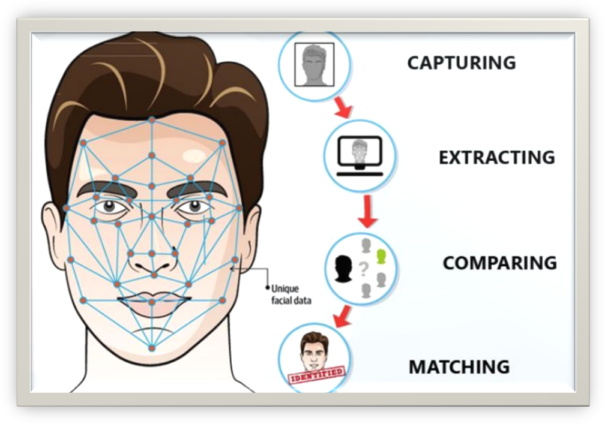

Methodology

Image Capture
A camera is placed away from the entrance to capture an image of the front of the student. And a further process goes for face detection.

Face Detection and Facial Features
The appropriate and effective facial detection algorithm constantly improves facial recognition. Several facial algorithms such as face-to-face geometry, construction methods, face geometry-based methods, Feature Invariant methods, Machine learning based methods. Out of all these methods Viola and Jones proposed a framework that gives a high
Detection rate and is also fast. Viola-Jones detection algorithm is fast and robust. So we chose Viola-Jones face detection algorithm, which uses Integral Image and AdaBoost learning algorithm as classier. We have observed that this algorithm yields better results in a variety of lighting conditions.

Pre-Processing
Extracting the face features it is called pre-processing. This pre-processes step involves specifying the extracted facial image and transforms to 100x100. Histogram Equalization is the most commonly used Histogram Normalization technique. This improves the contrast of the image as it extends beyond the intensity of the image, making it even clearer and constraint.

Database Development
As we choose biometric based system every individual is required. This database development phase consists of an image capture of each individual and extracting the biometric feature, and then it is enhanced using preprocessing techniques and stored in the database.

Post-Processing
In the proposed system, after recognizing the faces of the person, the names are show into a video output. The result is generated by exporting mechanism present in the database system. These generated records can be seen in real time video. This ensures that person whose faces are not recognized correctly by the system have to check in database. And thus, giving them the ability to correct the system and make it more stable and accurate.

Result & Conclusion

The code has been tested for known as well as unknown person and the successful output of a known person has been displayed by the subject name and that for an unknown person an unknown tag has been obtained.

Future Scope

- To identify more number of users at the same time at a faster rate with 100% accuracy.
- To communicate and welcome the person via speech modulation after successful recognition.

References

arxiv.org/ftp/arxiv/papers/1403/1403.0485.pdf
www.cin.ufpe.br/~rps/Artigos/Face%20Recognition%20Using%20Eigenfaces.pdf
www.mdpi.com/2227-7080/9/2/31
www.ojs.uma.ac.id/index.php/jite/article/view/3865
[1] Deshpande, N. T., & Ravishankar, S. (2017). Face Detection and Recognition using Viola-Jones algorithm and Fusion of PCA and ANN. Advances in Computational Sciences and Technology, 10(5), 1173- 1189.
[2] Kavia, M. Manjeet Kaur, (2016). “A Survey paper for Face Recognition Technologies”. International Journal of Scientific and Research Publications, 6(7).

